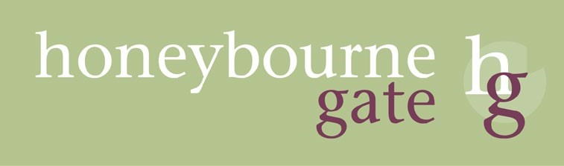 Key Sheet 4 February 2024

Qualifying Person – Fact sheet
When you are considering living at Honeybourne Gate you need to understand that you can only do so if you are what is called a ‘qualifying person’. A qualifying person is a person who is over 60, unless the landlord agrees otherwise, who can live independently and safely at Honeybourne Gate with the level of support that is available. We have to carry out an assessment to see if you meet this criterion and establish what sort of care you may need (if any) when you first move in. This assessment requires you to meet our General Manager at Honeybourne Gate to discuss your needs and general state of health.
We do not provide nursing care at Honeybourne Gate, so if you need the sort of care that can only be provided by a registered nurse being on the premises at all times then you cannot live at Honeybourne Gate.
However, if you have no care needs at present, or if you only need some additional personal care (such as help with dressing, bathing, etc) then the likelihood is that you meet the criterion of a qualifying person, and we will be able to support you to live independently in an apartment at Honeybourne Gate.
You will receive 1.5 hrs of domiciliary support in your apartment as part of the service charge but if you need more than this or additional personal care you can buy it from the on-site team. You will need to be able to afford the level of care that is determined at your assessment although for some people the Council will help with these costs. You may also be eligible for Attendance Allowance which can help with the cost.
You must understand also that your needs may change in the future. You can increase the amount of support you are buying from the on-site team but if you do not buy sufficient care for us to be able to look after you properly then you will no longer be a qualifying person and will have to move out. Also, if you develop a condition that means it is not safe for you to stay at Honeybourne Gate or that requires on-site nursing care then you will no longer be a qualifying person and will have to move out. Such conditions can, for example, include dementia that has progressed to the point that we cannot guarantee your safety or which has affected your behaviour to the extent that you are disturbing other residents.
Of course, we hope that once people move in, we will be able to look after them for as long as they want to stay. But you do need to understand that sometimes it is just not possible.
When you are buying a property at Honeybourne Gate all this is set out in the lease that you will be signing.
When you are renting a property at Honeybourne Gate then there is a Residency Agreement that sets it out and you will need to sign a copy, along with your Tenancy Agreement.

Signature & Date: …..……………………………………………………………………………………………………………………

